A circular pond, 3.6m in diameter, has a fence around it at a constant distance of 0.6m from the edge. Find the length of the fence (round to 1decimal place)

A cake shop sells birthday cakes that are 20cm in diameter, what is the shortest length of ribbon that would fit around the cake?

The plan shows the dimensions of an L shaped sitting room. The house owner wants to buy skirting board to go around the edge of the room, leaving gaps at the doors. What is the shortest length of skirting board he can buy?
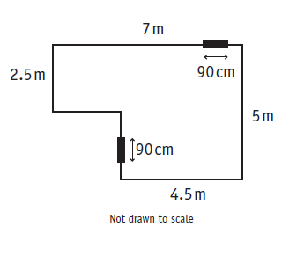

A semicircular window has a diameter of 1.6m. The window frame is made of plastic strips along the outside edge. What is the total length of the plastic strip around the window frame?

A lawn has the shape of a rectangle with a semicircular end. There is a concrete there is a concrete edging around the outside of the lawn. What is the length of the concrete?



